Ministry of Science and Higher Education of the Russian Federation
Peter the Great St. Petersburg Polytechnic University
Institute of Industrial Management, Economics and Trade Graduate School of Business Engineering

The work is admitted to defend Head of the Graduate School of Business Engineering
I.V.Ilin
Click or tap to enter a date.

GRADUATE QUALIFICATION PAPER

MASTER’S DISSERTATION

THESIS TOPIC

Field of study Click or tap here to enter text.
(code and name)
Educational program Click or tap here to enter text.
(code and name)

Completed by student gr. | N.P. Surname
Scientific Supervisor  Position, academic degree, academic rank | N.P. Surname
Consultant  for standards compliance | N.P. Surname

St. Petersburg Click or tap to enter a date.
SAINT-PETERSBURG POLYTECHNIC UNIVERSITY OF PETER THE GREAT
Institute of Industrial Management, Economics and Trade
Graduate School of Business Engineering
APPROVED
Director
of the Graduate School of Business Engineering
I.V.Ilin
Click or tap to enter a date.

TASK
for the completion of the graduation thesis (or qualification work)
to the student Click or tap here to enter text. Click or tap here to enter text. Click or tap here to enter text., group Click or tap here to enter text.

- Thesis title: Click or tap here to enter text.
- Deadline for submitting the completed work by the student: Click or tap to enter a date.
- Initial data for the work: Click or tap here to enter text.
- Contents of the work (list of questions to be developed):
Click or tap here to enter text.
- List of graphic materials: Click or tap here to enter text.
- Advisors for the work: Click or tap here to enter text. Click or tap here to enter text.
- Date of issuing the task: Click or tap to enter a date.

Scientific Supervisor of the graduation thesis Click or tap here to enter text. Click or tap here to enter text.
Accepted the task for execution Click or tap to enter a date.
Student Click or tap here to enter text. Click or tap here to enter text.

ABSTRACT

Click or tap here to enter text.pages, Click or tap here to enter text.figures, Click or tap here to enter text.tables, Click or tap here to enter text. appendices
KEYWORDS: Click or tap here to enter text.
The subject of the graduate qualification work is “Click or tap here to enter text.”.
A brief summary of the content of the thesis, including key factual information and conclusions. General requirements for the abstract are outlined in GOST R 7.0.99-2018 "System of standards for information, library and publishing affairs. Abstract and annotation. General requirements". The abstract is written in both Russian and English. The abstract should contain: the subject, topic, and purpose of the thesis; the method or methodology of conducting the thesis; the results of the thesis; the scope of application of the thesis results; conclusions. The abstract contains the main results of the thesis. The volume of the abstract text is determined by the content of the document - the amount of information, its scientific value, and (or) practical significance. The volume of the abstract text is from 1000 to 1500 printed characters.

INTRODUCTION

The introduction should justify the choice of the topic, characterize the current state of the researched problem, its relevance, practical and theoretical significance, and the degree of development of the problem. The aim of the thesis and the tasks necessary to achieve the aim must be specified. A brief description of the research object must be provided. The tools and research methods used in the work should be named, and a brief summary of the main sections of the thesis should be given. In the master's thesis, particular attention should be paid to the degree of elaboration of the research topic, identifying aspects that have not yet been disclosed, emphasizing the shortcomings of existing theories and research methods. The recommended volume of the introduction is 2-3 pages.

TABLE OF CONTENTS

INTRODUCTION 4
1. A 4
1.1. a 4
1.2. b 4
1.3. c 4
2. B 4
2.1. a 4
2.2. b 4
2.3. c 4
3. C 4
3.1. a Ошибка! Закладка не определена.
3.2. b 4
CONCLUSION 4
REFERENCES 4

A
The main text includes sections in which the course and results of the research are presented, and conclusions are drawn based on the results of the work. Specific requirements for the content of the work are determined by the methodological recommendations for the preparation of the thesis and are approved by the director of the higher education school, and may also be reflected in the state final examination program. General requirements for the content of the work are communicated to the students and posted on the website of the higher education school or institute. Typically, the main text of the thesis includes three sections, and for master's students, four sections are allowed. The sections of the explanatory note should have logical transitions throughout the work and be connected to each other in meaning.

a
$CR_{3}=s_{1}+s_{2}+s_{3},$ (1)

where СR₃ – The coefficient of concentration, %;
s₁, s₂, s₃ – Market share of the three largest companies at the moment, %.

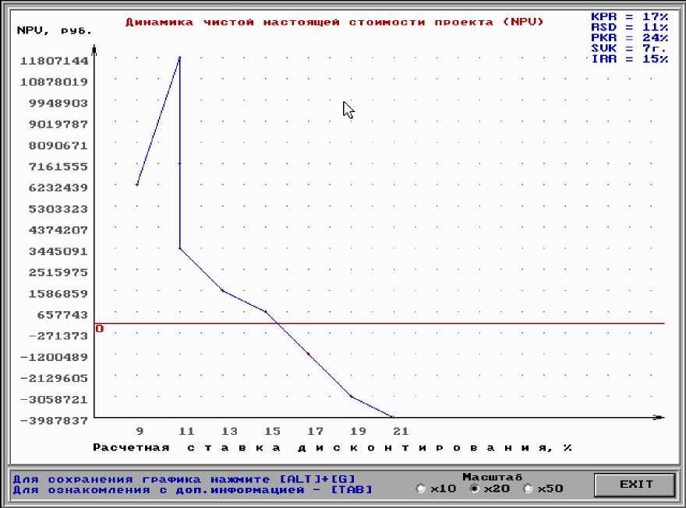

FIGURE 3.2 - Dynamics of NPV with changes in the values of RSD and PKR (compiled by the author)

Table 2.9 - Statistics of the application of impact measures to clients of PJSC "SBERBANK" for the years 2013-2015 (compiled by the author)

Indicators | Years
 | 2013 | 2014 | 2015
Preventive measures, units | 94 | 109 | 122
Violations detected, units | 121 | 144 | 187
Restrictions and prohibitions imposed, units | 71 | 86 | 93
Penalties, units | 97 | 128 | 155
Total penalties, thousand rubles | 265477 | 342678 | 455712

b

c

B

a

b

c

C

a

b

CONCLUSION

The conclusion contains outcomes based on the results of the work, as well as suggestions and recommendations. The conclusion formulates the outcomes of the conducted research. They cover all sections of the main part, including the introduction, and should concisely provide an overview of the content of the work, the results obtained for each task set in the work, their significance, validity, and effectiveness of the recommendations made in the work, as well as reflect the author's personal contribution to the development of the researched topic. The recommended length of the conclusion is 2-4 pages.

REFERENCES

The list of references is a mandatory part of the graduation thesis. It includes all literary sources, regulatory documents, and internet resources used in the work. Information about the sources used in the work is provided in accordance with their bibliographic description standards and in compliance with GOST R 7.0.5-2008 "System of standards for information, library, and publishing activities. Bibliographic reference. General requirements and rules for composition."
The information about the sources should be arranged in the order in which they appear in the text of the thesis and numbered with Arabic numerals. All sources listed in the references should be current and verifiable. Information obtained from confidential sources must not be disclosed without written permission from the data owners.
The reference list should not include materials from portals such as Wikipedia, Studopedia, and materials without authorship indication. All authors' works mentioned in the text of the thesis must be included in the list of references. This also applies to authors mentioned in the Introduction, when characterizing the degree of elaboration of the problem.
The reference list of the thesis should only include those sources that are cited in the text at least once. Simply including information sources in the list of references without linking them to the explanatory note text is not allowed.
Specific requirements for the structure and content of the bibliography are provided in the methodological recommendations for writing the thesis in the field of training.
- Download the style file using this link: GOST-R-7.0.5-2008.xsl.
- Copy the style file to: C:\Users\AppData\Roaming\Microsoft\Bibliography\Style
- Launch (or restart) Word and in the "References" menu, select the style "GOST R 7.0.5-2008 (sorting by the order of inclusion)". Save the document and work with the sources. When creating a source, be sure to specify the language — English or Russian, otherwise, English will be the default. (http://word-office.ru/kak-sdelat-spisok-literatury-po-gostu-v-word.html)

Regulatory and legal acts
- Гражданский кодекс Российской Федерации: части первая, вторая, третья и четвертая [Текст]. - Москва: Эксмо, 2020. - С. 841 - 843.

Standards
- ГОСТ Р 57564-2017 Организация и проведение работ по международной стандартизации в Российской Федерации [Текст] - М: Стандартинформ, 2017. - 43 с.
- ISO 9001:2015 "Quality management systems - Requirements" [Текст]. - IDT, 2015. - P. 10-11.

Patent documents
- Патент № 2638963 Российская Федерация, МПК C08L 95/00 (2006.01), C04B 26/26 (2006.01). Концентрированное полимербитумное вяжущее для «сухого» ввода и способ его получения : № 2017101011 : заявл. 12.01.2017 : опубл. 19.12.2017 / Белкин С. Г., Дьяченко А. У. - 7 с. : ил.

Book under the author's name
The book description starts with the author's last name if the book has no more than three authors.
One author
- Петушкова, Г. И. Проектирование костюма [Текст]: учебник для вузов / Г. И. Петушкова. - М.: Академия, 2004. - С. 398-400.
Two or three authors
- Кузовлев, В. П. Философия активности учебной деятельности учащихся [Текст]: монография / В. П. Кузовлев, А. В. Музальков. - Елец: Изд- во Елецкого гос. ун-та, 2004. - С. 144-165.
- Максимов, Н. В. Архитектура ЭВМ и вычислительных систем: [Текст] учебник для вузов / Н. В. Максимов, Т. Л. Партыка, И. И. Попов. - М.: Инфра- М, 2005. - 512 с.
Four authors
- Методы формирования сценариев развития социально- экономических систем [Текст] / В. В. Кульба, Д. Кононов, С. А. Косяченко, А.

В. Шубин. - М.:
СИНТЕГ, 2004. - 291 с.
Five or more authors
- Маркетинг [Текст]: учебник для вузов / С. Г. Божук, Л. Н. Ковалик, Т. Д. Маслова и др. - СПб: Питер, 2012. - С. 302-305.

Without an author (compiler, editor)
- Иллюстрированный словарь английского и русского языка с указателями [Текст]. - М.: Живой язык, 2003. - 1000 с.

Article from a collection of scientific works
- Думова, И. И. Инвестиции в человеческий капитал [Текст] / И. И. Думова, М. В. Колесникова // Современные аспекты регионального развития: сб. статей. - Иркутск, 2001. - С. 47-49.

Journal article
- Тарасова, Н. Г. Смена парадигм в развитии теории и практики градостроительства [Текст] / Н. Г. Тарасова // Архитектура и строительство России. - 2007. - № 4. - С. 2-7.

Bibliographic description of a document from the Internet
- Справочники по полупроводниковым приборам [Электронный ресурс]. - Персональная страница В.Р. Козака - Новосибирск: Ин-т ядер. физики, 2003]. - Режим доступа: http://www.lnp.nsk.su/%7Ekozak/start.htm/ (дата обращения: 23.03.2020).
- Члиянц, Г. Создание телевидения [Электронный ресурс]. - QRZ.RU: сервер радиолюбителей России - Режим доступа: http://www.qrz.ru/articles/article260.htm/ (дата обращения: 21.02.2020).

